Types of data base

1. Relational databases
2. Nosql databases
3. Column databases
4. Graph databases
5. Key-value databases

**Relational databases**

Table ko hum relation bolate hai

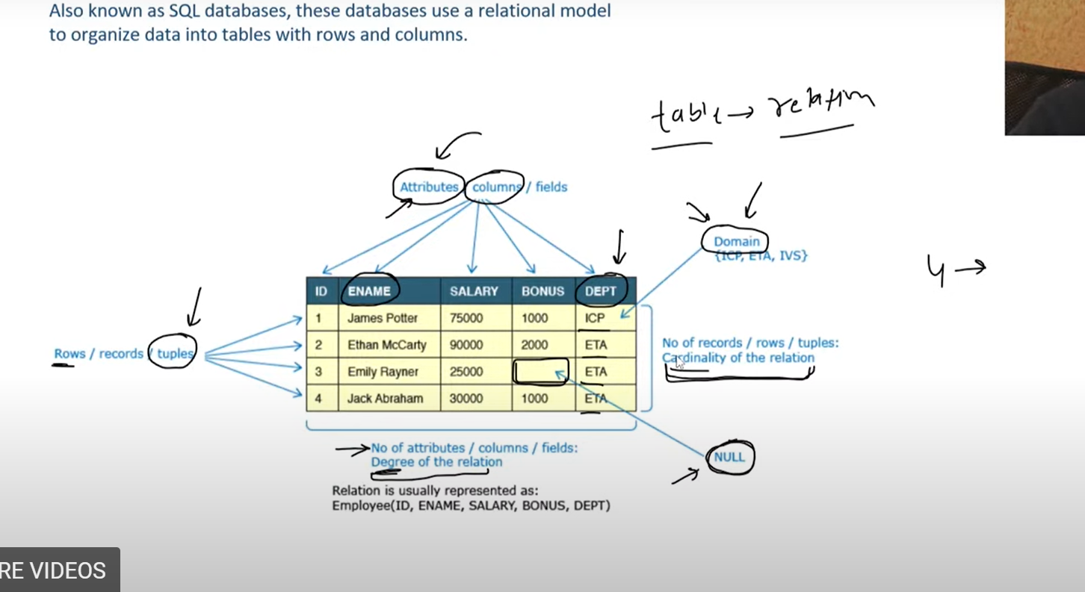

No of columns ko bola jata hai degree of the relation

No of row ko bola jata hai cardinality of the relation

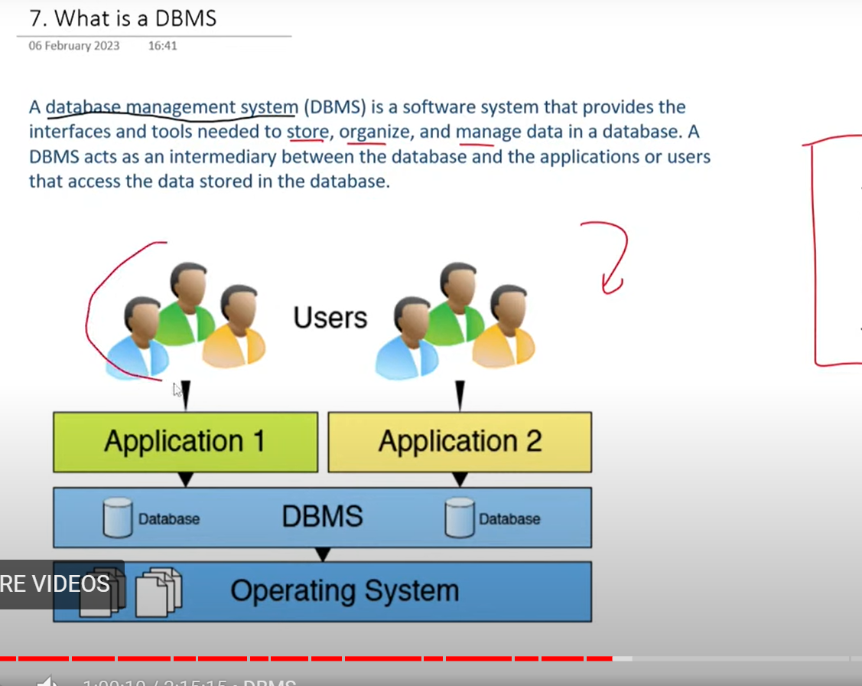

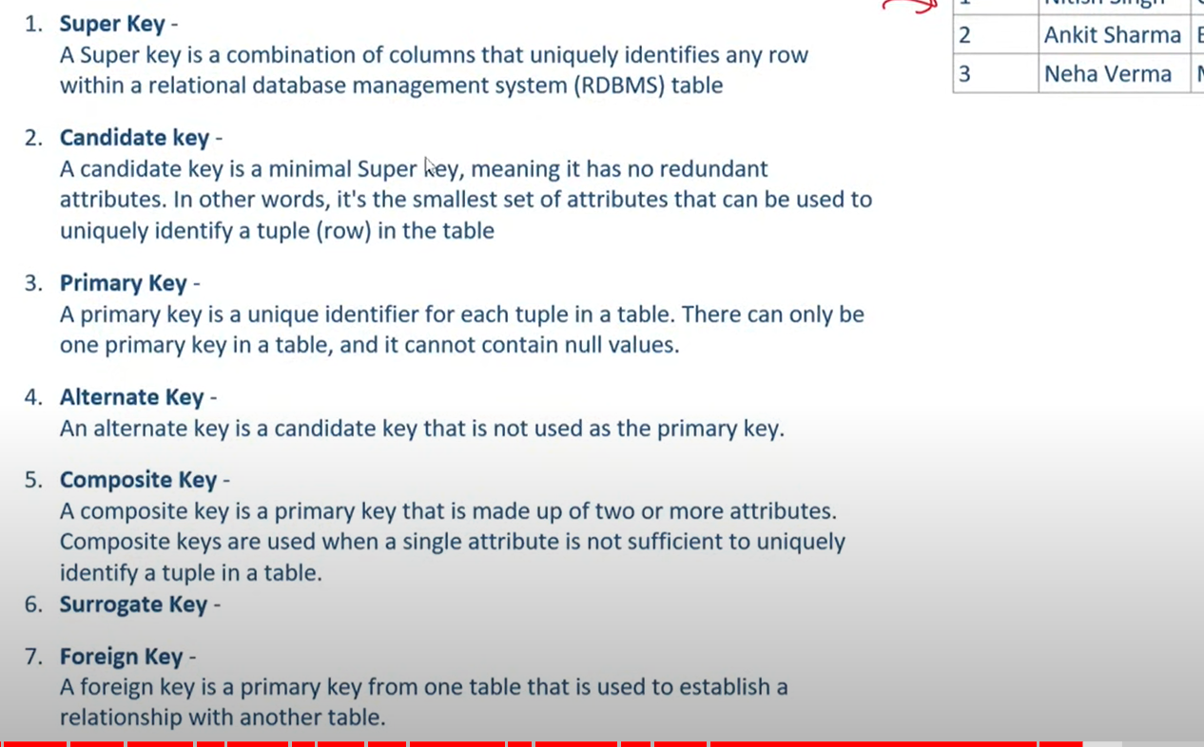

**Super key**

Sab column ko mila ke key bane usko super key bolenge

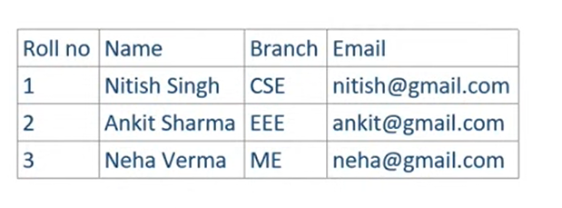

Jaise ki Roll no+ Name + Branch +Email ye sab mila ke key bane tho usko hum super key

**Candidate key**

Abhi candidate key kya hota hai agar upar wale example may dekhe tho roll no candidate key ban sakta hai kyun ki usko aur

Further divide nahi kar sakte same with email

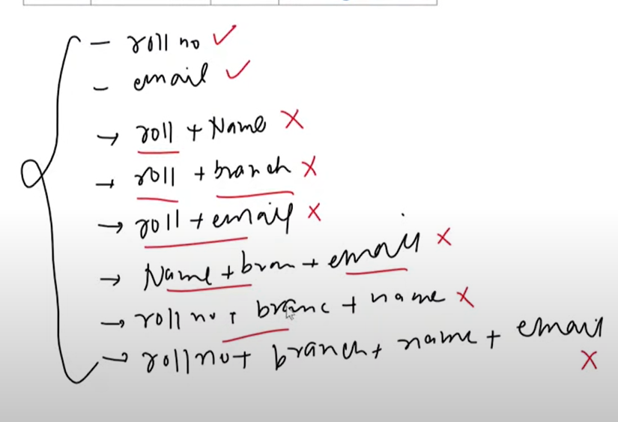

Ye upar diye hua pic may dekh sakte hai ki kon sa candidate key ban sakta hai aur kon sa nahi

**Primary Key**

Kya hota hai abhi isko aise samjho ki super key aap ki jantaa hogayi aur candidate key aap ki umidawar hogaye and usmay se jo jeeta usko hum primary key bana denge

Criteria for primary key

* Cannot be Null
* Cannot be duplicate
* Mostly numeric
* Small
* Constant

**Alternate key**

Candidate key – primay key = Alternate key

**Cardinality of relationships**

3 tarah ke relationship possible hai

1. One-to-one relationship
2. One-to-many relatioinship
3. Many-to-many relationship

One-to-one relationship

Person with driving license abhi idhar ak person ka ak he driving license ho sakta hai tho ismay one-to-one ka concept ayega



One-to-many relationship

Abhi ismay example student and unlogo ka branch

Abhi ismay 2 table lagega



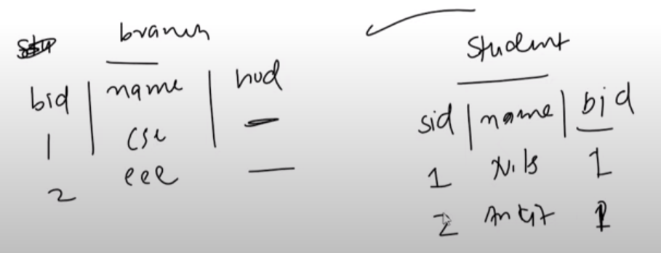

**Many to many relationship**



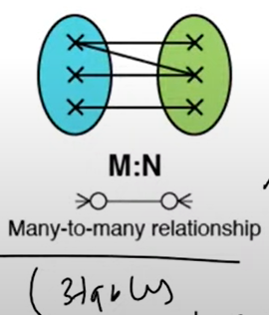

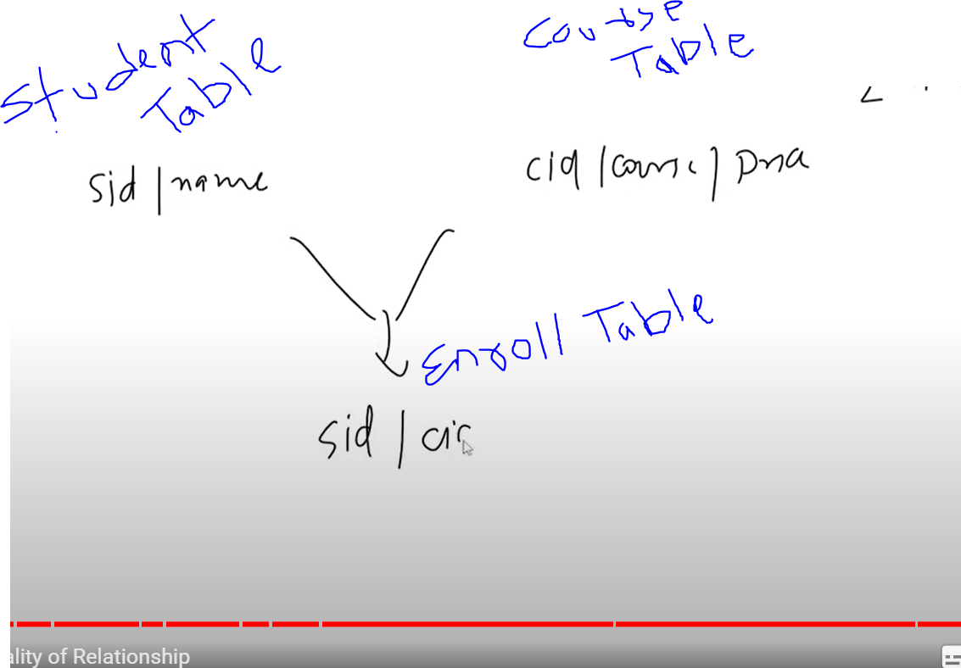

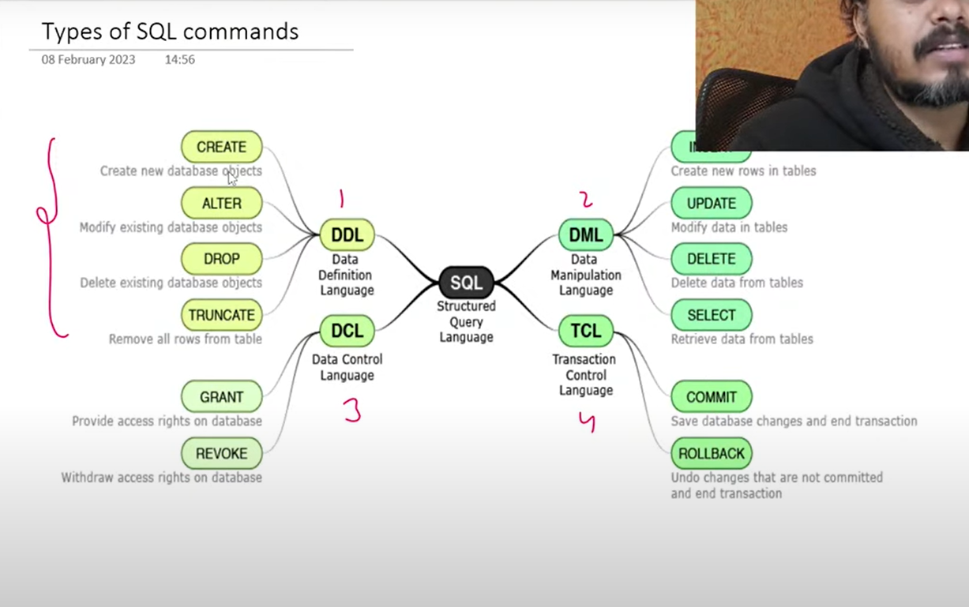



Abhi group by kaise kaam karta hai

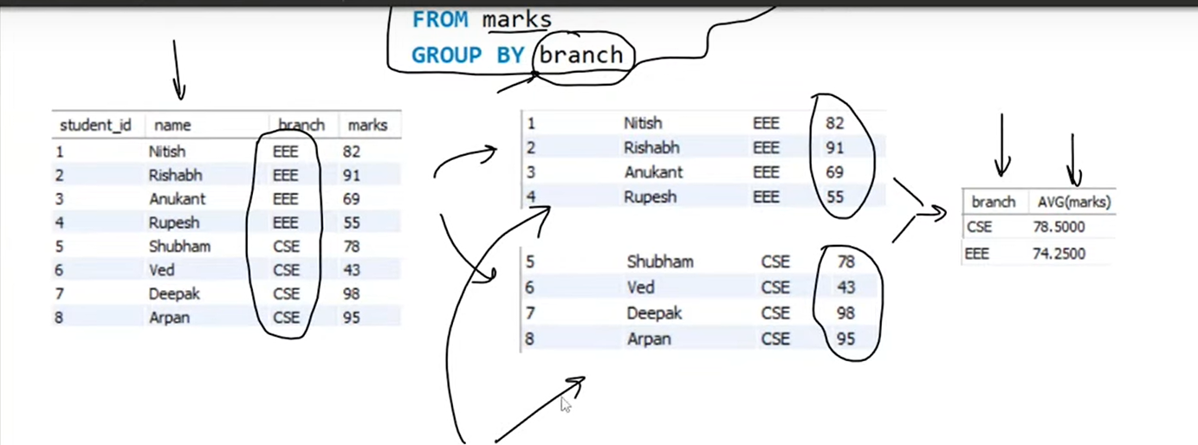

Groupby and windows function may ye difference hai ki groupby may pure row may result nahi dikahata but result

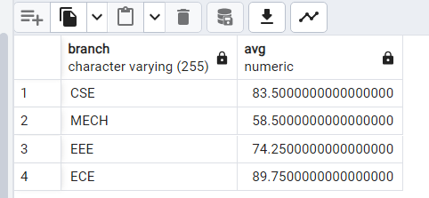

Aur agar window may dekho tho asia dihkata hai

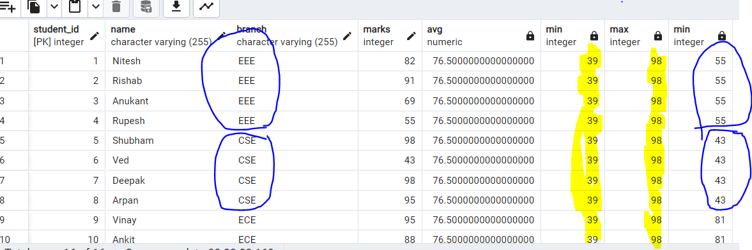

Windows may pure row may dikhata hai

**Sorting and Grouping**

Order by sorting ka kaam karta hai

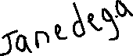

Limit x,y



Limit 10,2

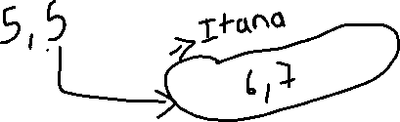

Abhi idhar dekhate hai query kon se order may kaam karta hai

FROM

JOINS

WHERE

GROUPBY

HAVING

SELECT

DISTINCT

ORDERBY

Employee

|  |  |  |  |  |  |  |
| --- | --- | --- | --- | --- | --- | --- |
| ID | ENAME | DOJ | SALARY | BONUS | DEPT | DESIGNATION |
| 1 | James Potter | 01-Jun-14 | 75000 | 1000 | ICP | PM |
| 2 | Ethan McCarty | 01-Feb-14 | 90000 | 1200 | ETA | PM |
| 3 | Emily Rayner | 01-Jan-14 | 25000 | 100 | ETA | SE |
| 4 | Jack Abraham | 01-Jul-14 | 30000 | NULL | ETA | SSE |
| 5 | Ayaz Mohammad | 01-Apr-14 | 80000 | NULL | ICP | SSE |

SELECT DISTINCT Dept From Employee WHERE Salary >30000 ORDER BY Dept

Sab se first From execute hoga

|  |  |  |  |  |  |  |
| --- | --- | --- | --- | --- | --- | --- |
| ID | ENAME | DOJ | SALARY | BONUS | DEPT | DESIGNATION |
| 1 | James Potter | 01-Jun-14 | 75000 | 1000 | ICP | PM |
| 2 | Ethan McCarty | 01-Feb-14 | 90000 | 1200 | ETA | PM |
| 3 | Emily Rayner | 01-Jan-14 | 25000 | 100 | ETA | SE |
| 4 | Jack Abraham | 01-Jul-14 | 30000 | NULL | ETA | SSE |
| 5 | Ayaz Mohammad | 01-Apr-14 | 80000 | NULL | ICP | SSE |

SELECT DISTINCT Dept From Employee WHERE Salary >30000 ORDER BY Dept

|  |  |  |  |  |  |  |
| --- | --- | --- | --- | --- | --- | --- |
| ID | ENAME | DOJ | SALARY | BONUS | DEPT | DESIGNATION |
| 1 | James Potter | 01-Jun-14 | 75000 | 1000 | ICP | PM |
| 2 | Ethan McCarty | 01-Feb-14 | 90000 | 1200 | ETA | PM |
| 5 | Ayaz Mohammad | 01-Apr-14 | 80000 | NULL | ICP | SSE |

SELECT DISTINCT Dept From Employee WHERE Salary >30000 ORDER BY Dept

|  |
| --- |
| DEPT |
| ICP |
| ETA |
| ICP |

SELECT DISTINCT Dept From Employee WHERE Salary >30000 ORDER BY Dept

|  |
| --- |
| DEPT |
| ICP |
| ETA |

SELECT DISTINCT Dept From Employee WHERE Salary >30000 ORDER BY Dept

|  |
| --- |
| DEPT |
| ETA |
| ICP |

Select count(*) from smartphone



Abhi count(*) ye sabhi rows ko count karta hai jaise niche wale table may 7 rows hai

|  |  |  |
| --- | --- | --- |
| brand_name | price | rating |
| oneplus | 14999 | 74 |
| samsung | 14999 | 84 |
| samsung | 45999 | 88 |
| realme | 14990 | 75 |
| vivo | 239999 | 81 |
| vivo | 21990 | 81 |
| poco | 9999 | 72 |

**Having clause**

Select ------- ke liye jo kaam where karta hai

Group by ---- ke having karta hai